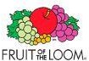
Kids Valueweight T-Shirts

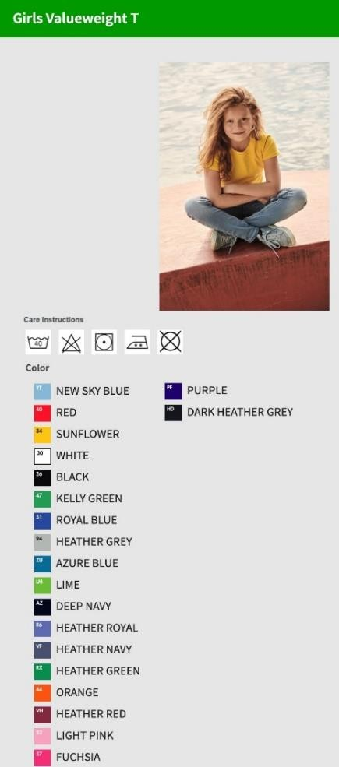  Style | Picture | Brand & style description | Colour | Colour Desc | 104 | 116 | 128 | 140 | 152 | 164 | TOTAL
0610050 |  |  | ZU | Azure Blue | 105 | 2.359 | 72 |  |  |  | 2.536
0610050 |  |  | 36 | Black | 784 | 708 |  | 2 | 18 | 388 | 1.900
0610050 |  |  | HD | Dark Heather Grey | 80 | 340 | 145 | 974 | 2.531 | 72 | 4.142
0610050 |  | Kids valueweight t-shirts | AZ | Deep Navy | 1.975 | 1.816 | 1.268 | 810 | 897 | 1.326 | 8.092
0610050 |  | Kids valueweight t-shirts | 57 | Fuchsia | 108 | 243 | 386 |  | 359 |  | 1.096
0610050 |  |  | RX | Heather Green | 139 | 122 | 11 | 509 | 841 | 1.666 | 3.288
0610050 |  |  | 94 | Heather Grey | 1.128 | 1.206 | 1.000 | 205 | 177 | 570 | 4.286
0610050 |  |  | VF | Heather Navy | 103 | 80 | 317 | 96 | 1.736 | 193 | 2.525
0610050 |  |  | VH | Heather Red | 136 | 144 | 3.060 | 2.250 | 1.648 | 1.425 | 8.663
0610050 |  | VE / PU: 72 Stück | R6 | Heather Royal | 760 | 131 | 653 | 1.023 | 1.430 | 1.579 | 5.576
0610050 |  |  | 47 | Kelly Green | 340 | 1.381 |  | 1.364 | 222 | 144 | 3.451
0610050 |  | Weiß: 160 g/m² | 52 | Light Pink |  | 72 | 1.094 | 856 | 2.003 |  | 4.025
0610050 |  |  | LM | Lime | 148 | 3.891 | 168 |  |  | 226 | 4.433
0610050 |  | Farbig: 165 g/m² | 44 | Orange | 2.837 | 2.023 | 568 | 216 | 1.579 | 469 | 7.692
0610050 |  |  | PE | Purple | 115 | 89 |  |  | 2.324 | 423 | 2.951
0610050 |  |  | 40 | Red | 1.924 | 354 |  |  |  |  | 2.278
0610050 |  |  | 51 | Royal Blue | 888 | 923 | 15 |  | 576 | 412 | 2.814
0610050 |  |  | YT | Sky Blue | 251 | 130 |  |  |  |  | 381
0610050 |  |  | 34 | Sunflower | 1.040 | 2.052 | 1.129 | 63 | 418 | 129 | 4.831
0610050 |  |  | 30 | White | 703 | 1.052 | 878 | 47 | 2.641 | 2.598 | 7.919
Total 610050 |  |  |  |  | 13.564 | 19.116 | 10.764 | 8.415 | 19.400 | 11.620 | 82.879

Packing Info: goods are packed in bundles mostly 72pc per carton; 1 Style / 1 color / 1 size per carton

